

**Spring 2024**

Submitted by: **Hassan Zaib Jadoon**

Registration No: **22pwsce2144**

Class Section: **A**

“On my honor, as student of University of Engineering and Technology, I have neither given nor received unauthorized assistance on this academic work.”

Submitted to:

**Engr. Abdullah Hamid**

15 March 2024

**Department of Computer Systems Engineering**

**University of Engineering and Technology, Peshawar**

**LAB 2:** **SHELL Programming (Part I)**

**Objectives:**

The aim of this laboratory is to learn and practice SHELL scripts by writing small SHELL programs.

The following are the primary objectives of this lab session:

* Understanding what a SHELL script.
* What is a SHELL script.
* Different kinds of SHELLs in UNIX.
* Why and where it is used.
* First simple SHELL script
* SHELL variables.
* User defined variables.
* System variables.
* Read only variables and wiping out variables.
* Assigning values to variables.
* Reading input

**Example 01:**

**Commands: SSH File**

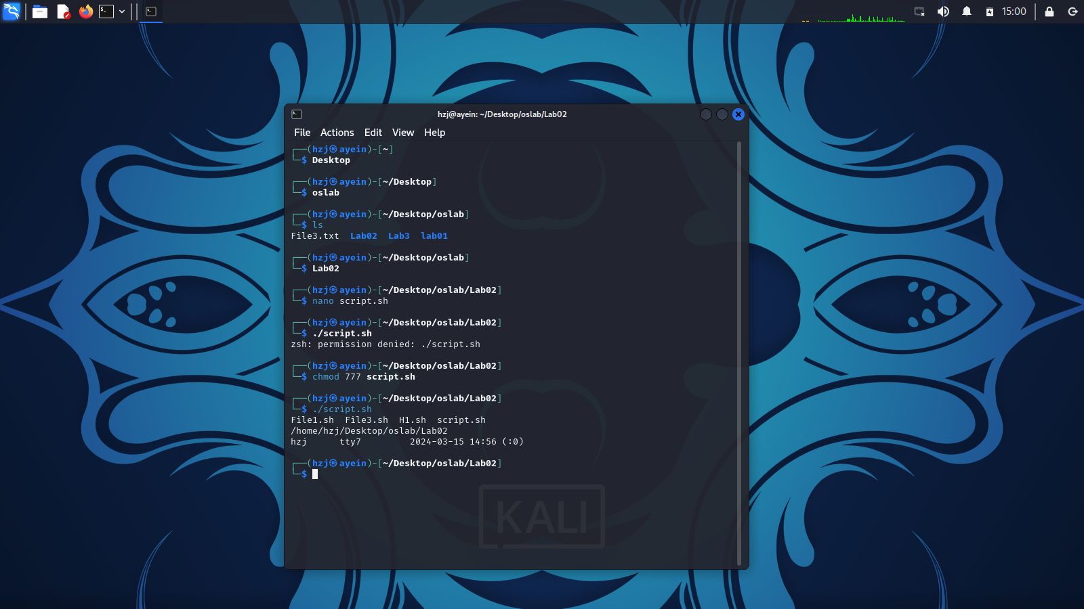 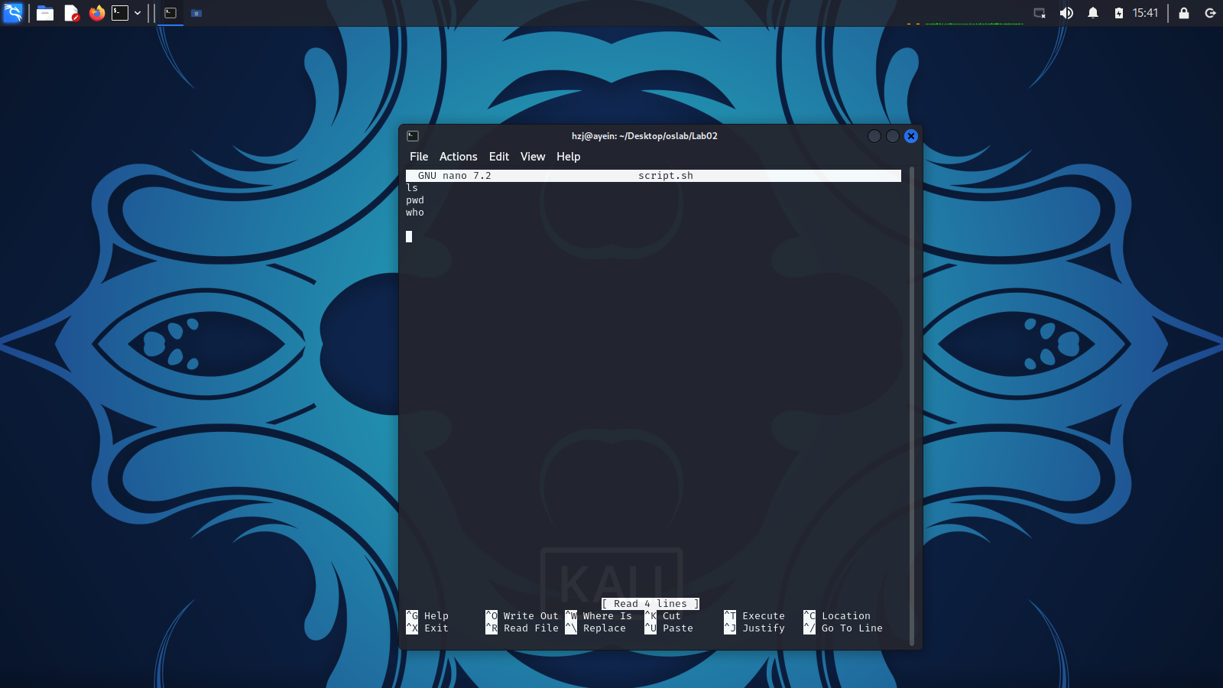

**Example 02:**

**Commands: SSH File:**

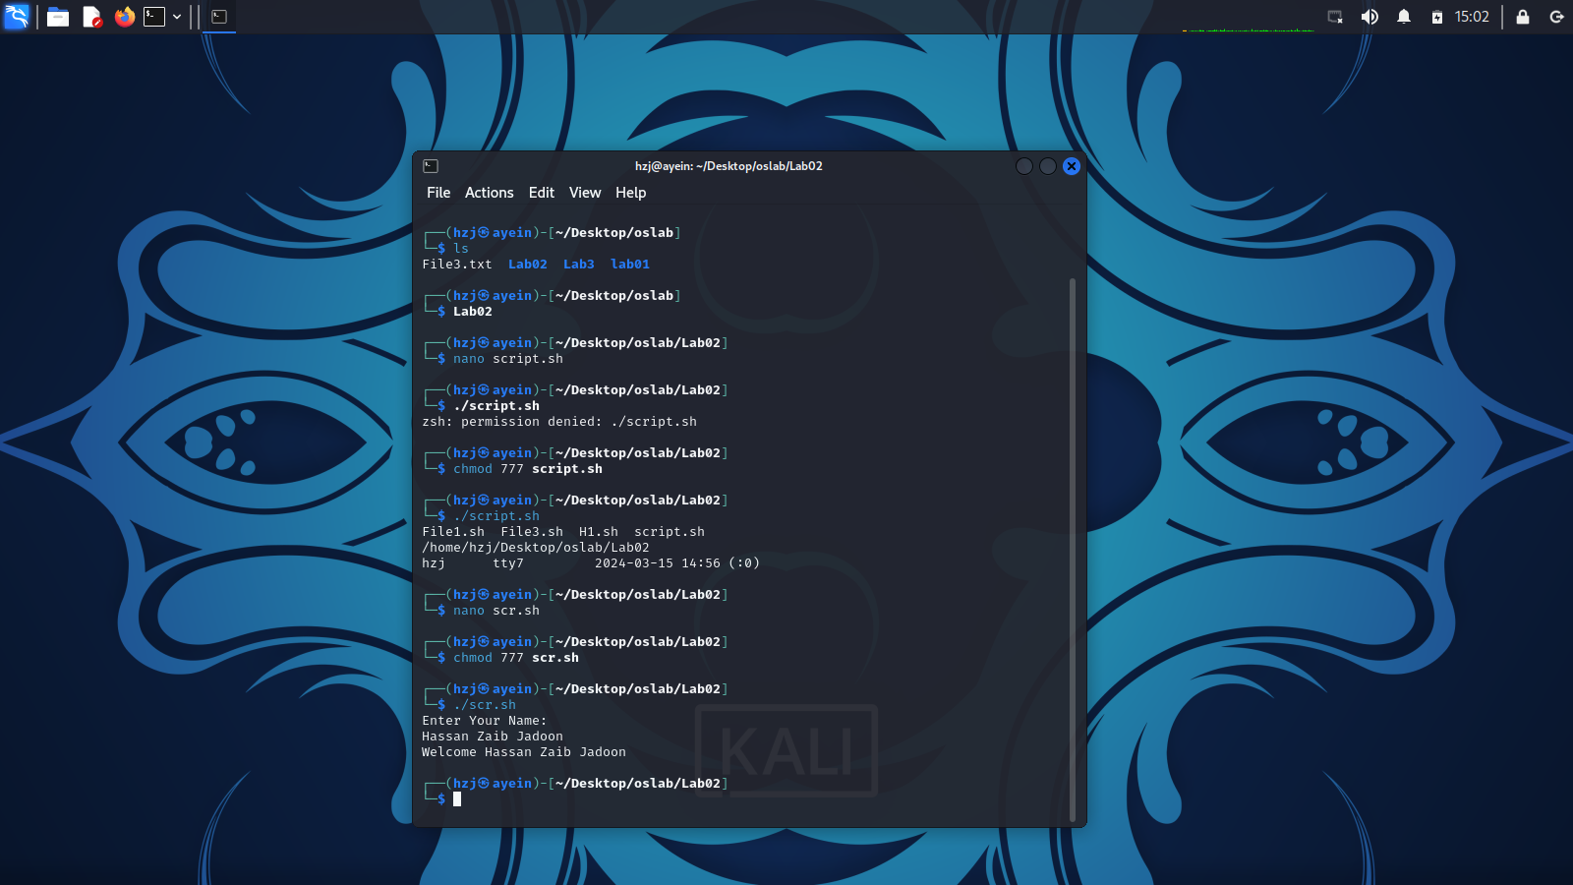 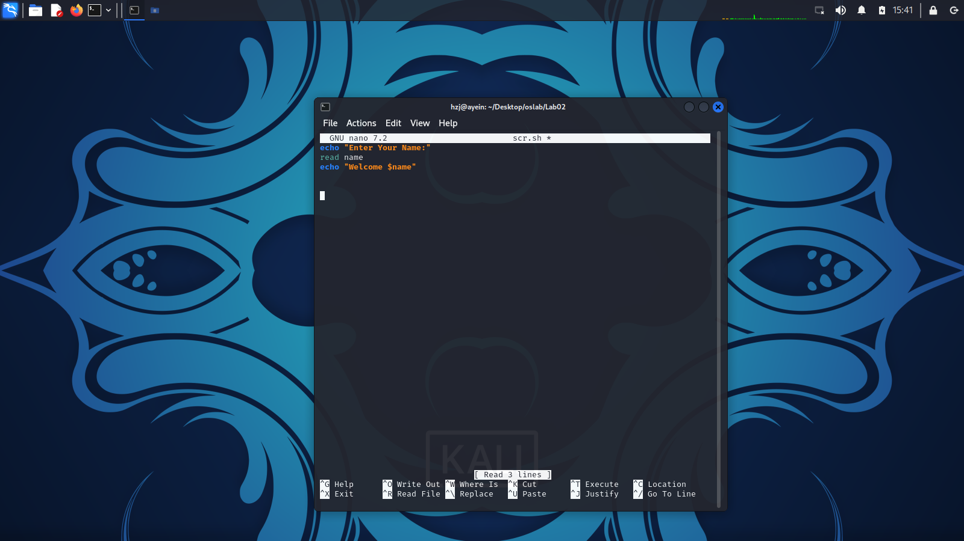

**Example 03:**

**Commands: SSH File:**

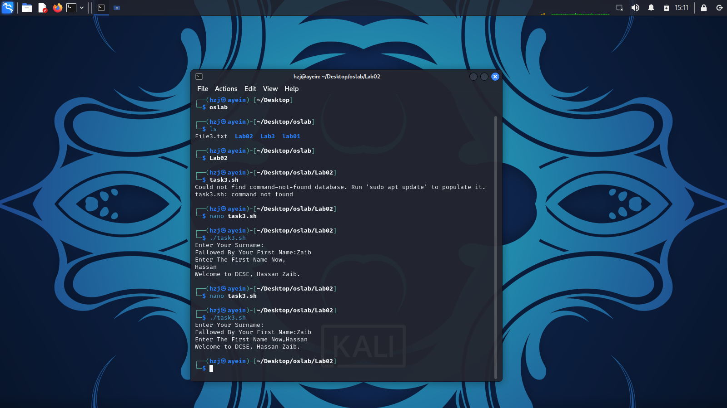 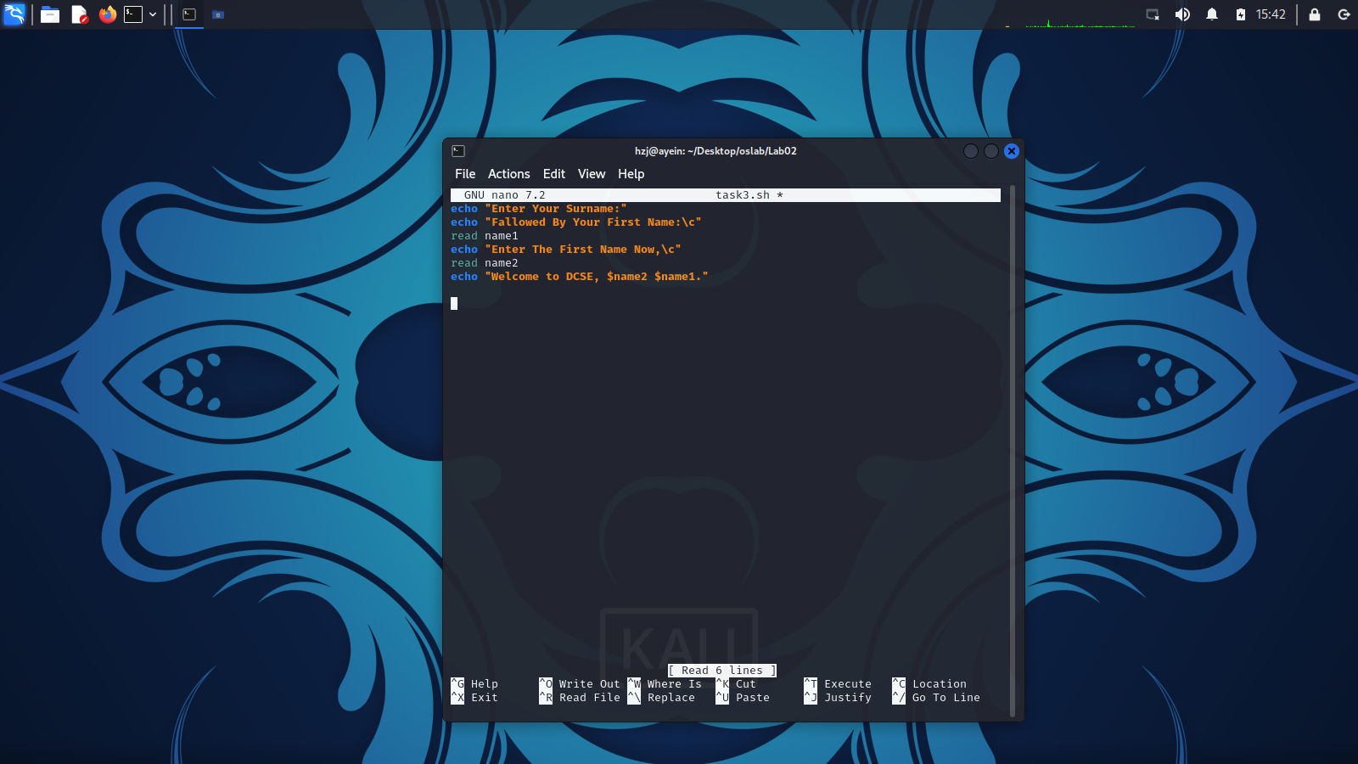

**Example 04:**

**Commands: SSH File:**

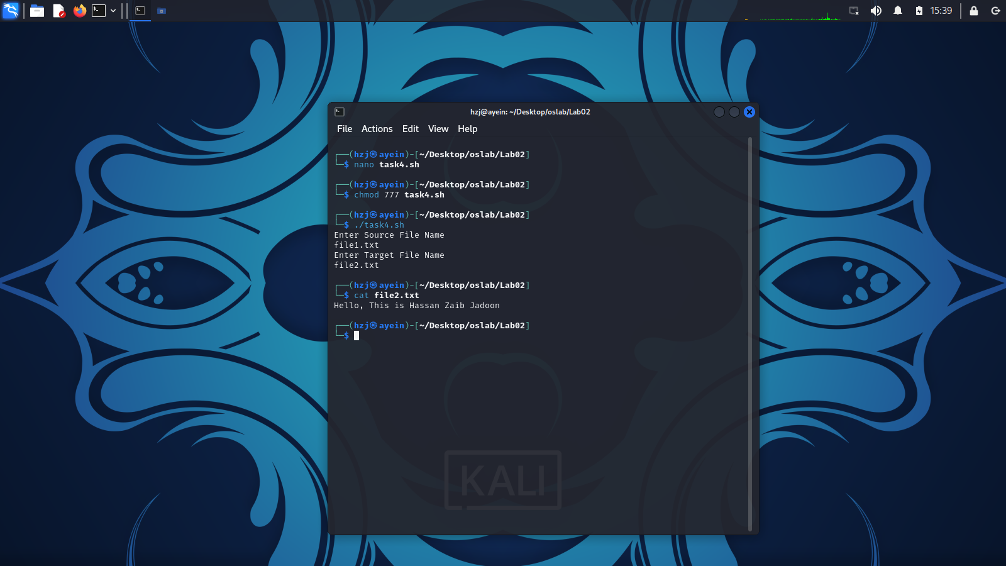 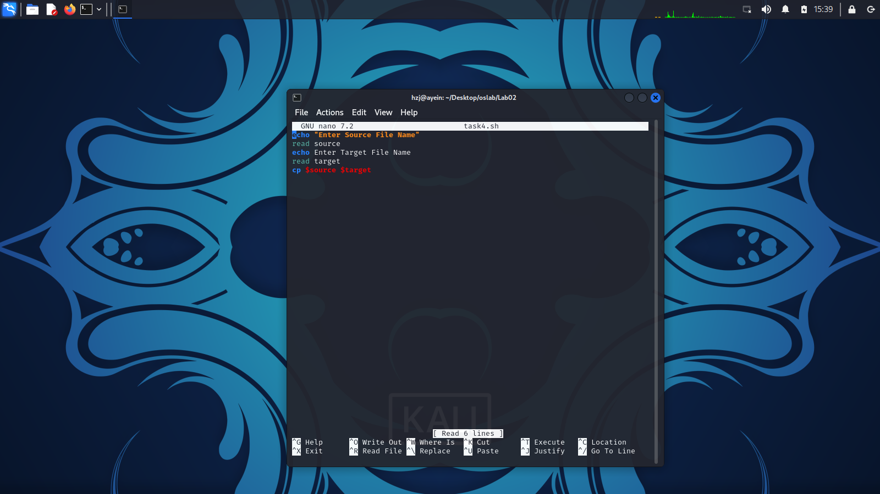

**Example 05:**

**Commands: SSH File:**

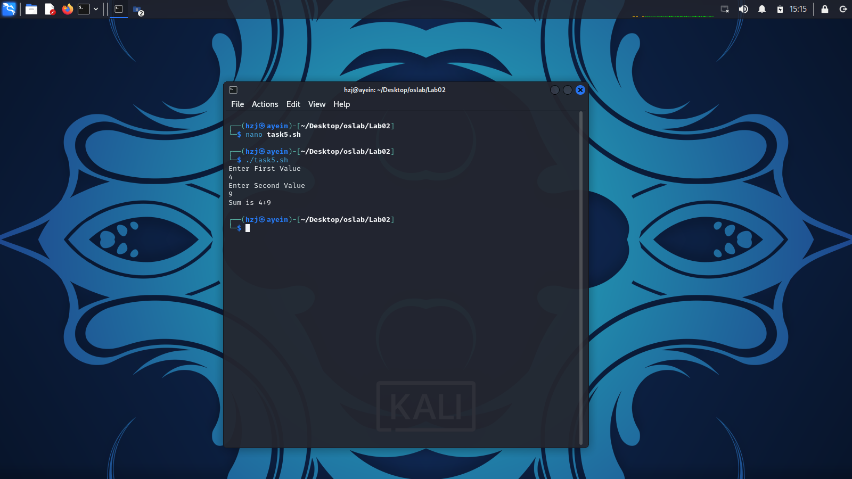 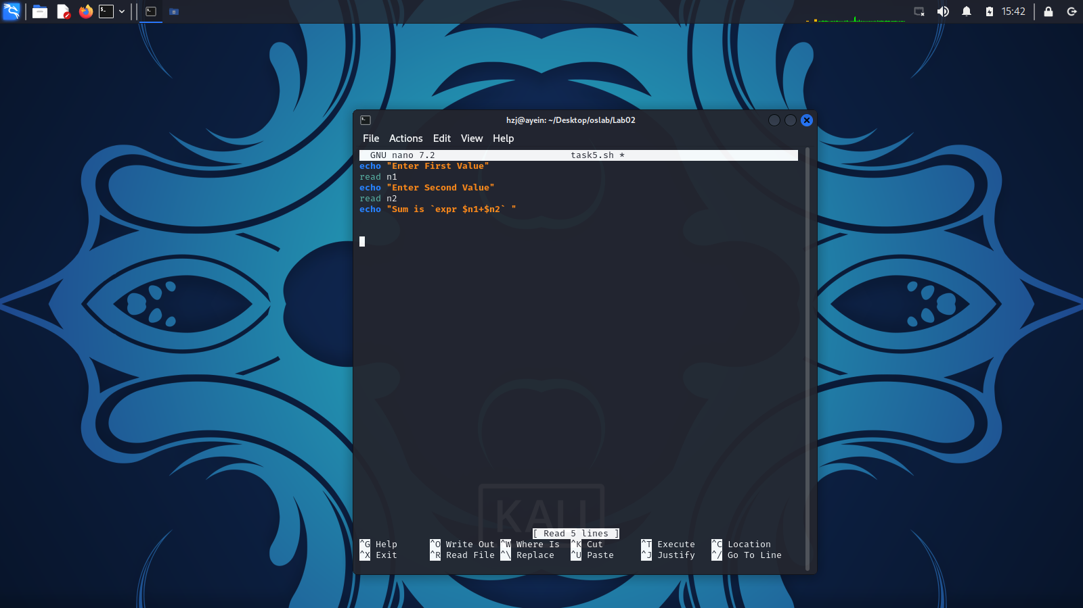

CSE 302L: Operating Systems Lab

LAB ASSESSMENT RUBRICS

|  |  |  |  |  |
| --- | --- | --- | --- | --- |
| **Marking Criteria** | **Exceeds expectation (2.5)** | **Meets expectation (1.5)** | **Does not meet expectation (0)** | **Score** |
| **1. Correctness** | Program compiles (no errors and no warnings).  Program always works correctly and meets the specification(s).  Completed between 81-100% of the requirements. | Program compiles (no errors and some warnings).  Some details of the program specification are violated, program functions incorrectly for some inputs.  Completed between 41-  80% of the requirements. | Program fails to or compile with lots of warnings.  Program only functions correctly in very limited cases or not at all.  Completed less than 40% of the requirements. |  |
| **2. Delivery** | Delivered on time, and in correct format (disk, email, hard copy etc.) | Not delivered on time, or slightly incorrect format. | Not delivered on time or not in correct format. |  |
| **3. Coding Standards** | Proper indentation, whitespace, line length, wrapping, comments and references. | Missing some of whitespace, line length, wrapping, comments or references. | Poor use of whitespace, line length, wrapping, comments and references. |  |
| **4. Presentation of document** | Includes name, date, and assignment title.  Task titles, objectives, output screenshots included and good formatting and excellently organized. | Includes name, date, and assignment title. Task titles, objectives, output screenshots included and good formatting. | No name, date, or assignment title included.  No task titles, no objectives, no output screenshots, poor formatting. |  |

**Instructor:**

Name: Engr. Abdullah Hamid Signature: